Supply Chain

Governance and Workforce Development Framework

(In Alignment with The Global Fund’s Supply Chain Roadmap)
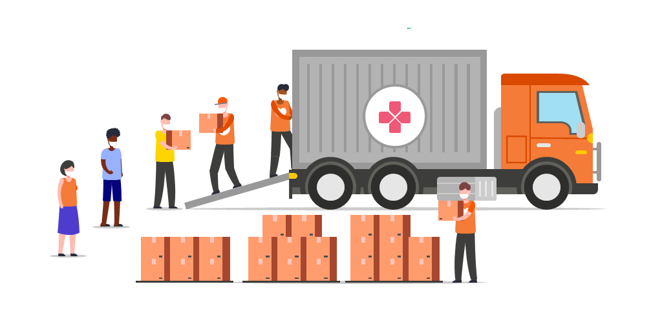

Document Title: G&WD Framework Logical Workflows

Version # | Date
1.0 | 03.08.2021
2.0 | 06.09.2021

Introduction
Governance and Workforce Development cannot be achieved through training only. It requires the recognition of the capacity gaps to be filled and the desire to fill those gaps. It also needs an opportunity to apply those capacities, once they are acquired, in an enabling environment. It also requires a proper mix of individual and collaborative work. Only then can capacities be turned into operational competencies that shall serve an organization.
Too often, the response to a governance or capacity issue has been an off-the-shelf pre-existing training. Although, some training can be a relevant part of a broader plan, but they can't just be the plan. The G&WD Framework has been designed to ensure that this “broader plan” is seen as an organizational priority and included in all the initiatives invested in by The Global Fund.
Governance and Workforce Development framework is hence, aimed towards greater stewardship and accountability from country stakeholders, resulting in sustainable initiatives contributing towards the national supply chain transformation agenda.
As part of the Implementation Methodology of the G&WD framework, there is a matrix of initiatives developed on the back of two existing models / frameworks: a) TGF’s EDIS model for workforce development and People that Deliver’s Theory of Change for Human Resources for Supply Chain. This matrix (provided in the Guidance Document: SHEET 3) presents several initiatives that can support supply chain organizations in developing a robust supply chain workforce by prioritizing on staffing, skills, working conditions and motivation aspects in a structured manner.
However, often these initiatives are difficult to design as they come under the purview of Human Resource Management. In discussion with The Global Fund’s supply chain team, ten (10) initiatives have been identified for which detailed process maps / workflows have been developed, to support TGF officers and country staff to understand the initiatives, set expectations and design Terms of References. Along with these workflows, several resources have also been provided to get a more detailed understanding of the concepts and processes while designing these initiatives.
How can these Workflows be Used?
The logical result-based frameworks can be used by TGF officers (such as supply chain specialists, or HPM specialists) in designing Scope of Works for GWD initiatives based on demand from country counterparts. These workflows provide a clear and standardized view of results, outputs, activities and deliverables and key preconditions and checks for any initiative, making it easier to design an on-ground initiative. However, the responsible officer will have to always add contextual information about the country and may have to adjust some portions of an initiative based on actual need in a country. These processes are developed based on the assumption that no workforce development initiative has been conducted in the country. However, in reality, there may have been initiatives undertaken in the past by a partner, and there may be ongoing initiatives. Hence, the workflows are not ‘Prescriptive’ and should not be used as it is without making them specific to a country’s needs.

Understanding a GWD Logical Workflow
The workflow is designed as a specific plan that is geared towards specific outcomes. Just like any logical framework, one way to work this out is to start from expected results and go backward.
- The GWD initiative are categorized as per EDIS Phase and HR4SCM Theory of Change Pathways. These categories are identified in the beginning of the workflow.

- The Expected Result(s) should be first agreed upon, described and articulated in a clear manner. These results should be in line with expectations from the country partner.

- The Output(s) contributing to this result are then listed. These are direct and measurable outputs from any initiative.

- Activities contributing to the output(s) are then described in detail. For any GWD initiative, there can be more activities than what is listed in the workflows depending on the country context. These activities represent the work to be funded by The Global Fund.

- Pre-conditions and Checks are some preparatory activities / conditions which should ideally be met in order to successfully implement a GWS initiative. Not meeting the preconditions and checks will result in significant risks and may result in lower or negligible impact. This can also be understood as the “assumptions” of a logical framework or a theory of change. A risk analysis tool is provided in the Sheet 4 of the Guidance Document.

- Several Key Resources (tools, guidelines, reports, case studies etc.) that can be used to design Terms of References and implement the GWD initiative are also identified in the workflows. Some of these resources are guidance documents, while some are finished products. These resources can be contextualized and used at the country level depending on the need. However, it is not mandatory to always use these resources. All the resources are provided in the Guidance Document under Sheet 7 and can be downloaded as per requirement.

- Finally, some qualitative and quantitative Key Performance Indicators are listed along with an estimated Timeline for TGF supply chain team to understand how to monitor execution of such initiative.

Flow of Document
The document is designed as per TGF’s EDIS model to create a logical sequence of workflows. Initiatives that fall under ‘Engage’ are presented first, followed by ‘Design’, ‘Implement’ and ‘Sustain’.
Within the same EDIS phase, initiatives are then presented as per Theory of Change pathways starting with ‘Staffing’, followed by ‘Skills’, ‘Working Conditions’ and ‘Motivation’.
The following page lists out all the workflows presented in this document and a link to quickly go to that page.

LIST OF WORKFLOWS

1. Supply Chain professionalization framework recognized in country 5

2. Workforce Planning & Estimation of Supply Chain staff across functions 10

3. Training Evaluation Framework and Implementation 14

4. Occupational Health and Safety Policies for Supply Chain Organization 19

5. Implementing and Socializing Code of Conduct in supply chain organization 23

6. Incentives & recognition program linked to learning and performance of staff and organization 27

7. Integration of Supply Chain Curriculum in Health Degree Programs 31

8. Continuous learning strategy in National Supply Chain Organization 35

9. Work environment supports physical, social, and emotional well-being of staff 40

10. Continuous supportive supervision to improve staff performance 45

- Supply Chain professionalization framework recognized in country

Category: ENGAGE | SKILLS
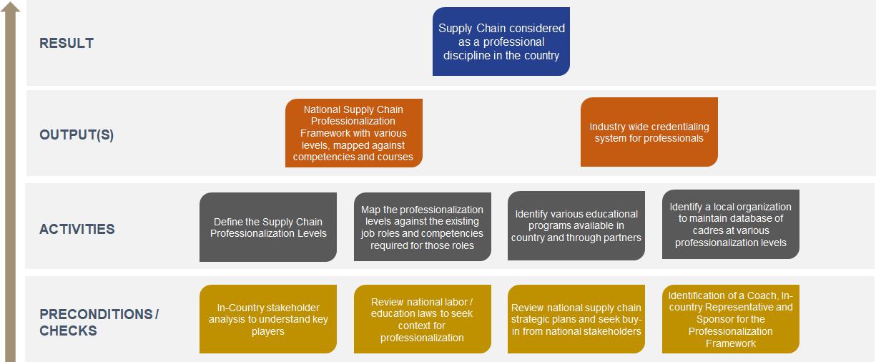
The graphic presents a high-level overview of the logical workflow. Details are provided below.

- Introduction
Supply chain is a key enabler for managing health programs such as for HIV, TB, Malaria, COVID-19 etc. in a country. In the countries focused by The Global Fund in their current Supply Chain Roadmap, there are multiple donors and agencies who are supporting systems strengthening activities to improve availability of lifesaving health commodities (which is also one of the goals for The Global Fund).
An ongoing challenge, however, is ensuring that adequate supply chain management (SCM) professionals, who have the competencies to deliver effective SCM, are available to countries’ health supply chain organizations, and across the health network in the country. Hence, a national supply chain professionalization framework is required which can:

Cognizant of the thematic roles proposed by the Supply Chain Roadmap, and based on thematic role 3 of Capacity Development, a national professionalization framework can support systematic development of supply chain as a profession in the country, resulting in strengthening of the public health systems, process sustainability and strengthening of capabilities of not just the health supply chain organization but the entire sector nationally.

- Expected Result

The high-level result or outcome for this initiative must be that ‘Supply Chain is considered as a professional discipline in the country’ even by the health professionals. This would mean that working with health supply chain organization such as Central Medical Stores, Logistics Management Units etc. will be considered as a Career of Choice rather as a Career by Chance.
A national professionalization framework will bring a labour market shift in the country, where public and private sector supply chain organizations will thrive and support each other. Educational institutions will consider the requirements of the sector while developing and delivering the curriculum on supply chain, while health disciplines (such as pharmacy, nursing, medicine) may also start considering supply chain as a skill to be learned.
In the long term, a professionalized sector will strive to achieve excellence in the health supply chain, resulting in better service delivery, lowered costs and improve efficiency, and hence, resulting in a resilient and sustainable supply system, which is one of the goals for The Global Fund.
The professionalization framework will also bring standardization of work across health supply chains which is currently a key challenge being observed by various experts (Comprehensive Workforce Systems Approach. Dec 2019. USAID PtD SAPICS), while bringing the cadres working in the private and public sector at the same level of expertise.

- Output(s)

The main output of this initiative is a National Professionalization Framework which sets the standards for education and work across the country (preferably for both public & private sector), using a labour market approach. The professionalization framework must also include:
- A competency framework for supply chain cadres,
- Various supply chain roles mapped against those competencies,
- Educational Opportunities (academic) currently available in the country mapped against the competencies,
- Other educational opportunities (vocational / professional) available in the country or through partners mapped against the competencies,
- A methodology for supply chain credentialing in the country through a national organization (such as associations e.g., Pharmacy Council / Association or CPD providers etc.) to promote career pathways.

- Activities

The activities under this initiative must be able to bring various national stakeholders together and get a consensus on the professionalization framework and structure. This may take time and several iterations; hence, the in-country representative and the Sponsor must be ready to collect feedback and revise the activities when required. Key activities include:
- Defining the supply chain professionalization levels: The professionalization levels define the education, skills level, and standard job role for the cadre. Various global organizations use 4-5 professionalization levels, such as, Associate—Practitioner—Specialist—Professional—Leader. However, each country must decide whether these 5 levels work for them, depending on the current organization and educational structures of the country.
- Mapping of the professionalization levels against the current job roles: Initially this can be done only for public health sector including for the supply chain organization and the public health network (e.g., Ministry of Health, public health facilities (hospitals, health centres etc.). Later, this can be done for private sector roles as well.
- Identify educational programs available in the country: Map the professionalization roles and the job roles against existing education programs in the country. For example, Academic Courses (Pharmacy Assistant Course, B.Pharm, M.Pharm, Diploma or Masters in Supply Chain), Vocational Studies (Certification on supply chain, Sales and Marketing, Logistics etc.). Advocacy for the providers to include the key competencies in their curriculum can be done.
- Identify other professional development programs which the country can avail: There are several professional development programs which are available, which must be mapped against the levels. For example (Certifications provided by APICS, CILT, CIPS, CIPD etc., other certification or diploma courses in supply chain provided by global organizations)
- Develop a credentialing system in the country: A national organization must be selected which must maintain these standards described in the professionalization framework. This can either be the Supply Chain Organization of the country or an independent authority (like a council, or a CPD authority), which maintains a database of professionals who have supply chain credentials as per the professionalization levels.

- Pre-condition and checks

This initiative has been categorized at the ‘Engage’ level of the EDIS model since it includes engaging with several national and international stakeholders and their involvement is critical in developing this framework. This initiative is also critical for the other initiatives under the ‘Skills’ pathway and sets a benchmark for all the other initiatives.
Hence, before beginning this initiative, key checks and pre-conditions must be met.
Pre-condition:
This initiative would work best if three different sets of organizations / individuals are selected at the beginning:
- Coach: Individual or organization who fully understands the need for professionalization and can support the country in developing this framework. This is the individual or organization that The Global Fund Supply Chain Team can contract.

- In-Country Representative: This individual or organization is a country-based stakeholder who has full understanding of the health and supply chain context in the country and knows various stakeholders to be involved in this initiative. The role of this stakeholder to bring all stakeholders together for this initiative. This can be the Principal Recipient, or an in-country organization selected by TGF. This organization can also be a partner organization to the Coach.

- Sponsor: This can be an individual or a group from National Structures of the country, e.g., from Ministry of Health, or a governing board including members from various organizations (such as MoH, MoF, Private sector association, Ministry of Education etc.). This individual or group will be responsible for the governance of the initiative along with The Global Fund.

Checklist:
- Conduct an in-country stakeholder analysis, such as, Academic Institutions, Private sector supply chain / logistics providers, Professional Associations, other partners who would be important to involve in this initiative.
- Review national labor and education laws / policies to seek context and background to professionalization.
- Review national health supply chain strategic plans and seek buy-in from the Ministry of Health or Supply Chain Organization as they would be the central stakeholder in this initiative.

- Estimated Timeline

This is a long-term initiative and can be broken down into different phases depending on the country’s plans. In total, it may take 2-3 years in setting up a full supply chain professionalization pathway in a country.

- Key Resources

- Library of Competencies and Designations for Health Supply Chains (developed by People that Deliver)
- Collection of roles and job descriptions for Health Supply Chains (developed by People that Deliver)
- Mapping of Education for Health Supply Chains (developed by People that Deliver)
- Professionalization Framework Advocacy Flyer (developed by People that Deliver)

These are global resources and must be used as benchmarks or standards and adapted for use in the country.

- Monitoring & Evaluation

Since this is a long-term initiative, a monitoring and evaluation mechanism must be instituted to check progress and mitigate issues in a timely manner. Some indicators that can be used to evaluate the progress are provided here.

Qualitative Indicators | Sources / Means of Verification
- Agreement for supply chain professionalization framework across various stakeholders  - National supply chain competency framework is ratified by the sponsor and disseminated to all stakeholders involved  - Academic institutions agree to develop competency-based curriculum  - Professionalization framework is part of national supply chain strategic plan  - Validation of supply chain job roles across public health & private sector | - Project Reports  - National Strategic Plans  - Minutes of Meeting  - Official letters / circulars
Quantitative Indicators
- Number of stakeholders part of Sponsor Team
- Number of stakeholders involved in the initiative
- Number of iterations to finalize the professionalization framework
- Budget allocated by National Stakeholder for operationalizing the framework
- Number of educational providers identified as part of the credentialing system

- Workforce Planning & Estimation of Supply Chain staff across functions

Category: DESIGN | STAFFING
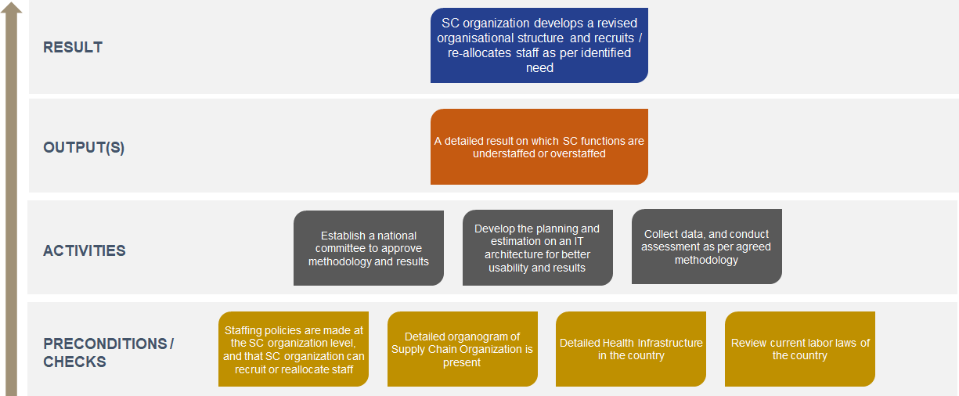
The graphic presents a high-level overview of the logical workflow. Details are provided below.

- Introduction

There have been severe health supply chain staffing shortages reported in various countries. Sometimes, staff are misallocated geographically or functionally which contributes to treatment gaps and stock outs at the service delivery points. It is quite common in countries for pharmacists, nurses or sometimes physicians to have the secondary role of collecting logistics data and make logistical decisions, along with the primary role of service delivery. This high workload often results in lower efficiencies in both service delivery and logistics management. There is shortages of logistics staff in several countries, and while some countries have dedicated staff, they may not be allocated uniformly across the chain.
In the past, some tools have been developed that help program managers in systematically make staffing decisions for health workers depending on workload and activity standards. However, these tools are seldom used for supply chain functions to design workforce planning scenarios and allocate staff according to the need of the supply chain functions at various tiers.
Workforce Planning and Estimation in Supply Chain may lead to the following outcomes:
- Match workforce as per demand,
- Minimize stock outs,
- Improve supply chain efficiency,
- Minimize treatment gaps.

- Expected Result

Several supply chain organizations are looking to expand their operations or improve supply chain management in the country by establishing a dedicated team/organization who manages the overall supply chain functions from planning, quantification to transportation of products to service delivery points. It is important that the constitution of the supply chain organization is optimized, depending on the size of the country and supply chain network design.
Hence, a workforce planning & estimation activity results in development of a ‘Revised Organizational Structure for the supply chain organization’ based on which staff can either be recruited or reallocated.
The workforce planning activity should also be conducted as per various supply chain functions so that all functions have adequate number of staff for its scope of work. The scope of workforce planning can be decided to also include how many staff are required at a service delivery point to manage those functions which affect supply chain. However, this must be prerogative of the country.

- Key output(s)

The main output of the workforce planning initiative should be a dashboard which shows the number of staff required by the supply chain organization and those areas/functions which are either under or over staffed.
Furthermore, it should also support the supply chain organization in designing the most appropriate organizational structure based on the scope of its operations.

- Activities

Workforce planning and estimation is quite a technical and complex assessment and requires direct expertise in:
- Human Resource Management
- Labor Laws of the country
- Research methodologies
- Analytics

Hence, an appropriate service provider must be chosen for this initiative who can design the activity as per the need of the country, while keeping in mind the country context. The provider must also demonstrate IT capabilities, or if not showcase how the assessment will be done using basic MS-Excel or similar tools. The key activities to be planned in this initiative are:
- Establishing a national / organization committee to oversee the initiative: The initiative requires several strategic decisions to be taken. For example, the scope of the estimation, key objectives etc., which must have consensus from leadership at the national level
- Mapping of Supply Chain: The levels of supply chain must be mapped and identified for the exercise. All levels must be named, and their role in supply chain must be clearly understood.
- Develop methodology for assessment and Design Tool for workforce estimation (develop IT capabilities for better usability): Using the global tools which are available, design a methodology and a tool with an IT infrastructure that can support data collection, scenario planning and show results in a dashboard. The methodology and tool must be duly approved by the committee.
- Collect data and analyse results: Using a team of collectors, who must be trained, data from various supply chain levels (using a sample) must be collected to be fed into the system for assessment.

- Preconditions and Checks

There are some countries where Human Resource policies and actions are not under the control of the supply chain organization (for example in Ethiopia, the Civil Service Commission manages most human resources issues for Ethiopian Pharmaceutical Supply Agency). In such a scenario, revising organizational structures and deducing under and over-staffing may not be of much value, unless there is a directive from the national authority to do so.
Hence, before beginning this initiative, it must be ascertained that Staffing policies are made at the SC organization level, and that SC organization can recruit, dismiss or reallocate staff.
Moreover, before beginning of this initiative, some other checks must also be done, such as:
- The current organizational structure and a detailed health infrastructure must be available, (if not, they must be developed at the beginning of the project)
- The labor laws of the country must also be reviewed to list any challenges that the supply chain organization may face from the outcome of this initiative,
- The scope of supply chain operations / processes conducted by the supply chain organization must also be understood
- Finally, any similar work must be identified and consulted.

- Estimated Timelines

If majority of preconditions and checks are positive, then the key activities and output for this initiative can be achieved in 6-9 months’ time.

- Key Resources

- Workforce Optimization Tool (developed by People that Deliver)
- Workforce Indicators of Staffing Need (developed by World Health Organization)
- Library of Competencies and Designations for Health Supply Chains (developed by People that Deliver)
These global resources should be reviewed and consulted before developing the methodology for the Workforce Estimation exercise.

- Monitoring & Evaluation

Qualitative Indicators | Sources / Means of Verification
- Ability of the supply chain organization to get the revised organizational structures and allocation of staff approved,  - Reported improvement in supply chain efficiency after reorganization and reallocation (6-12 months after the exercise) | - Project Reports  - Surveys / Assessments  - Official letters / circulars
Quantitative Indicators
- Number of meetings organized with the national committee to discuss methodology, preparation and results,
- Number of data collectors from the supply chain organization,
- Stock out rates before and after reorganization
- Product availability at the SDPs before and after the reorganization

- Training Evaluation Framework and Implementation

Category: DESIGN | SKILLS
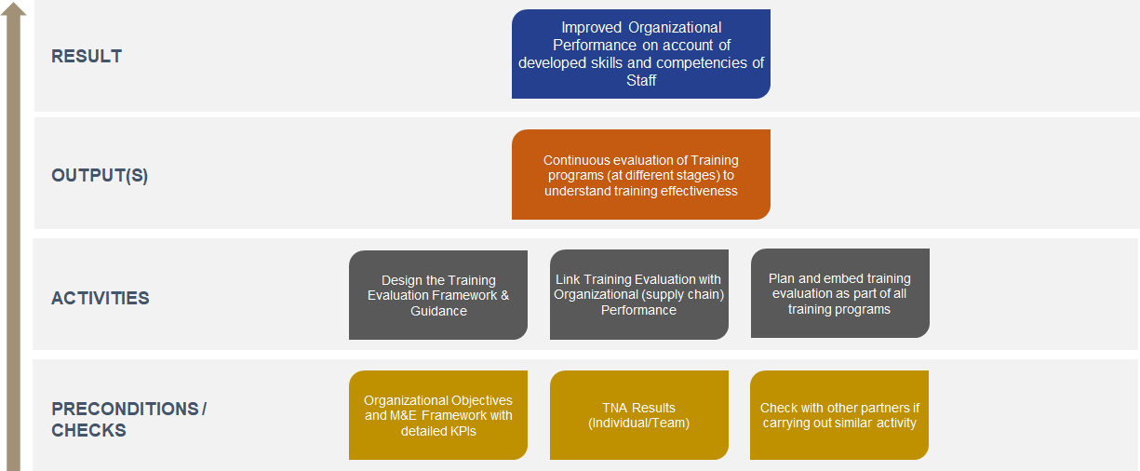
The graphic presents a high-level overview of the logical workflow. Details are provided below.

- Introduction

Training is a critical process for enhancing productivity and organizational performance. The management of these training processes is central to their effectiveness. In private sector, successful organizations emphasize significantly on continuous training where:

Public health supply organizations have made significant efforts to ensure that their training strategies are aligned with organization performance and improved health outcomes, but they are still unable to demonstrate the efficiency and cost-effectiveness of their investment in training and its contribution to organizational outcomes. Given the importance of in-country supply chains to public health systems, assessing the contribution of training to overall supply chain performance is critical.
There are a few training evaluation models developed globally, such as TOTADO by Birdi, Success Case Method by Brinkerhoff, Learning evaluation model by Anderson, Kaufman’s model of learning evaluation or The Kirkpatrick model of evaluation. The most commonly used method of Training Evaluation is the Kirkpatrick Model, however, the key for supply chain organizations is to be able to align training programs with organizational objectives and a method to evaluate how much training has contributed to achieving those objectives.

- Expected Result

Over the last decade, a significant amount of funds has been spent on organizing professional training programs on health supply chains and several related functions. In fact, annual work plans, and strategic plans developed by many countries still feature a substantial amount of training programs for the supply chain and related staff.
Unfortunately, these training programs are not often linked to organizational or program objectives, and a theory of how new skills / competencies developed by staff will be used to improve supply chain or program processes.
Hence, a detailed training evaluation framework and implementation results in understanding, ‘Improvement in Organizational Performance on account of Training’. This can support the rationale of refresher training programs and developed of advanced training and development of staff.
A detailed training evaluation framework will not only help the supply chain organizations (& donors) to understand the results from budget spent on training, it will also support the organizations to realize a continuous and circular manner of linking organization performance with training need.

- Key output(s)

The key output for the Training Evaluation initiative should be establishment of a continuous process where training programs, acquired skills, and linked organizational objectives are evaluated.
The evaluation must be done at different stages, for example – During the training, At the end of a Training program and between 3-6 months after completion of a training program. If the supply chain organization has a dedicated Training or Human Resources unit, this unit should be responsible for this continuous evaluation and reporting on how training has supported organizational objectives.

- Activities

Designing a training evaluation framework is an intensive work process and requires extensive experience in adult learning methodologies, monitoring and evaluation and knowledge of supply chain in order to link the training evaluation with organizational objectives.
In order to achieve this, a service provider can be selected who works alongside a dedicated team from the national supply chain organization to develop the detailed framework, support the national team in understanding data collection and reporting mechanisms. The role of the service provider can finish once the evaluation framework is approved by the leadership team, and 1-2 training programs are jointly evaluated (with national team) and reports produced. The overall initiative can take between 12-15 months.
The entire process may also be done electronically if there is a sustainable internet bandwidth in the country. The key activities to be planned in this initiative are:
- Designing the Training Evaluation Framework: A training evaluation framework needs to be designed with detailed guidance on how to evaluate if training were aligned to business objectives, the effectiveness of training and if training contributed to meeting those objectives. This should also include data collection strategies.
- Linking Training Evaluation with Organizational Performance: Training programs must be linked with Organizational Objectives, which in this case would be related to supply chain objectives or KPIs. Several supply chain organizations have now developed detailed KPI lists for their organizations and also allocated them to various departments. The training initiatives must be aligned to the achievement of those KPIs, for example;

A KPI can be: Reduce expired or damaged items in Inventory from 10% to 3%
To achieve this KPI, the organization can plan training on Good Warehousing Practices, Inventory Management methods and adhering to FEFO methods. The training can be followed by on job supervision and mentoring.
The training evaluation framework, hence, design a method, where it can be analyzed as to how the behaviors of staff changed following the training, which may result in improvement of the KPI. A Return-on-Investment measure can also be applied here, where budget allocated to this training can be compared against the cost savings that was achieved due to reduction in expiry and damages.
- Planning and Embedding Training Evaluation Strategies for all Training Programs: Once the training evaluation framework and data collection strategies are approved, evaluation must become part of all training programs organized for/by the supply chain organization. The service provider should also train the internal staff on the data collection instruments (quantitative and qualitative), while supporting them in evaluating a few training programs.

- Preconditions and Checks

The training evaluation framework stems from the organizational objectives and KPIs as described by each organization in their strategic plans or sometimes a dedicated document on KPIs used by organization to measure supply chain effectiveness.
In order to have a meaningful training evaluation framework, it is critical that the organization already has their objectives and KPIs finalized for a 3-5 year period. Otherwise, the training evaluation framework will not have any basis of suggesting whether training has resulted in supply chain effectiveness.
In addition to this key Pre-condition, the service provider must also look for the results for Training Need Analysis if conducted in the organization. Although, not overly critical, the results of TNA will support in linking the key training identified (during the TNA) with organizational objectives / KPIs, and the training evaluation framework.

- Estimated Timeline

The objective of this initiative is to support the national supply chain organization in instituting a structured training evaluation process which can be implemented during all training programs. The core part of the initiative can take between 12-15 months where the service provider develops the framework, the guide, implementation tools, and coaches the national staff in conducting the evaluation. However, some form of mentoring can also take place post completion of the first phase and may last another 12 months.

- Key Resources

- Kirkpatrick Four Levels of Training Evaluation – 1st Edition (By James D and Wendy Kayser Kirkpatrick)
- eBook by WaterShed LRS – Essentials of Learning Evaluation
- Training Evaluation for Public Health Supply Chain, People that Deliver (Draft)

- Monitoring & Evaluation

Qualitative Indicators | Sources / Means of Verification
- Ability of the national team to understand and apply the training evaluation framework,  - Training evaluation framework being adopted as a key resource by the national supply chain organization,  - Ability to show relationship between organizational objectives / KPIs and Training outcomes. | - Project Reports  - Surveys / Assessments
Quantitative Indicators
- Number of Training Programs Evaluated in one year,
- Number of surveys conducted in one year,
- Number of staff reporting positive improvement in performance due to training.

- Occupational Health and Safety Policies for Supply Chain Organization

Category: DESIGN | WORKING CONDITIONS
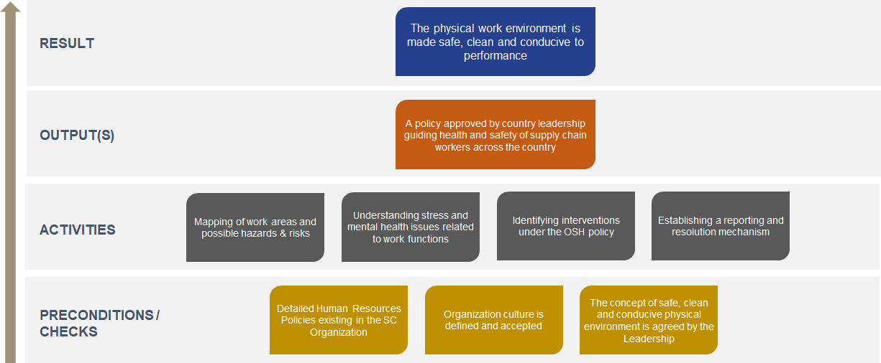
The graphic presents a high-level overview of the logical workflow. Details are provided below.

- Introduction

Unsafe and unhealthy working conditions often result from a combination of underlying causes, such as governance gaps, missing or weak policy frameworks, insufficient knowledge and resources about the issues, unsustainable operational practices, and the absence of an organizational culture of prevention & health promotion at national and sub-national workplace levels of a supply chain organization.
Occupational Safety and Health (OSH) is a multidisciplinary activity that aims to:
- Protect and promote the health of workers by preventing and controlling occupational diseases and accidents,
- Eliminate occupational factors and conditions hazardous to health & safety at work (e.g., eliminate risk of hazard while storing chemicals in a warehouse),
- Develop and promote healthy and safe work environments,
- Enhance the physical, mental and social well-being of workers.

Due to the nature of the work, health supply chain organizations have relatively higher environmental and occupational safety hazards than similar organizations working in the health sector. Therefore, these organizations should ensure that they put a safety system in place to use, receive, handle, distribute and store medicines, medical supplies and medical equipment.
An OSH policy for health supply chain organization is even more important considering the impact of the COVID-19 pandemic seen across the globe on health professionals. It is critical for health supply chain organizations to safeguard the health and safety of staff involved in distributing medicines and supplies.
- Expected Result

Working conditions are one of the four key pathways leading to optimization of work performance, resulting in supply chain effectiveness and availability of commodities at service delivery points.
A critical element of improving working conditions is the understanding and regulation of occupational safety and health of workers involved in health supply chains. As the physical work environment is made safe, clean and conducive to performance, it results in improved morale and ability of staff to focus on work.
A dedicated Occupation Safety and Health policy under the overall Human Resources policy will ensure that health supply chain organizations are committed towards maintaining a healthy and safe environment for the workers.

- Key output(s)

The key output for this initiative should be an approved policy document which can guide health and safety of supply chain workers across the country.
The policy document should also clearly mention key responsibilities of the employer (i.e., the health supply chain organization) and the employees, describe key health and safety hazards applicable to the work and how the organization will ensure mitigation. Finally, the policy must also mention key personnel responsible for upholding the integrity of the policy who would lead with the key interventions or implementation of the policy.

- Activities

There are several Occupational Safety and Health policies developed across the globe which can be used as a reference for this work. One of the key references used can be from People that Deliver – Standard Human Resources Policies Package for Health Supply Chain Organizations.
However, the policy must be developed with contextual understanding of the country, relevant to applicable national laws and in coherence with organization human resources policies. Hence, to do that, following activities must be undertaken:
- Mapping of all work areas where the policy will be applicable: The policy must include all work areas across the organization, in order to include specific health & safety needs. For example, requirements for a staff member who works at an office would be different than a staff member who works at a warehouse.

- Mapping and evaluation of all hazards and risks applicable to work areas: Based on the mapped work areas, all possible hazards and risks must be discussed with staff and identified to be part of mitigation strategies. Any diseases which may result from specific work performance must also be identified.

- Understanding how work contributes to stress and affects mental health of staff: Before drafting the policy, stress must be put in to understand how various job roles and work environment affects the mental well-being of staff and amounts to stress.

- Identifying various interventions that the organization can support to improve health and safety of workers: In discussion with leadership, the policy must identify various interventions to improve safety and health of workers across the organization. There can be variety of interventions that can be instituted as part of the policy and must be thoroughly vetted and approved by the leadership of the organization.

- Reporting & Resolution Mechanism: The policy must include development of a health & safety committee who should manage the reporting of issues by staff and support the staff in mitigating those issues.

There can be other activities while undertaking the developing of Occupational Safety and Health policy, but the ones mentioned must always be considered.
- Preconditions and Checks

The Occupational Safety and Health policy must be part of broader Human Resources policies package. Ideally, OSH policy must be part of the Human Resource policy, however, since HR policies are not quite comprehensive in health supply chain, OSH policies are quite often missing.
Hence, a key pre-condition for OSH policy is presence of Human Resource policies in the organization as it would set the background for OSH policy and the HR department / unit (in collaboration with OSH committee) would be responsible to engage with staff issues related to safety & health.
In addition to this, it must be verified and agreed with the organization’s leadership that there is a defined organization culture which is widely accepted across the organization. The organization culture should also state that well-being of staff is of paramount importance to the organization, which should form the basis of OSH policy. Moreover, there must be importance placed by the leadership for safe, clean and conducive physical environment.

- Estimated Timeline

This initiative can take 9-12 months to complete the core activities if all pre-conditions are met. However, getting leadership support, and finding a dedicated HR team to manage this initiative can take time.
- Key Resources

- Standard Human Resources Policies Package for Health Supply Chain Organizations, People that Deliver, 2021.
- Building Human Resources for Supply Chain Management, Theory of Change, People that Deliver, 2019
- Occupational Health, A Manual for Primary Health Care Workers, WHO, 2001

- Monitoring & Evaluation

Qualitative Indicators | Sources / Means of Verification
- Health & Safety processes adopted by the organization based on the policy,  - Positive impact on staff as a result of the policy, | - Project Reports  - Surveys / Assessments
Quantitative Indicators
- Reduction in number of work-related accidents in the work areas,
- Number of OSH issues reported to the OSH committee in a year,
- Number of issues resolved by the OSH committee as per the policy in a year.

- Implementing and Socializing Code of Conduct in supply chain organization

Category: IMPLEMENT | WORKING CONDITIONS
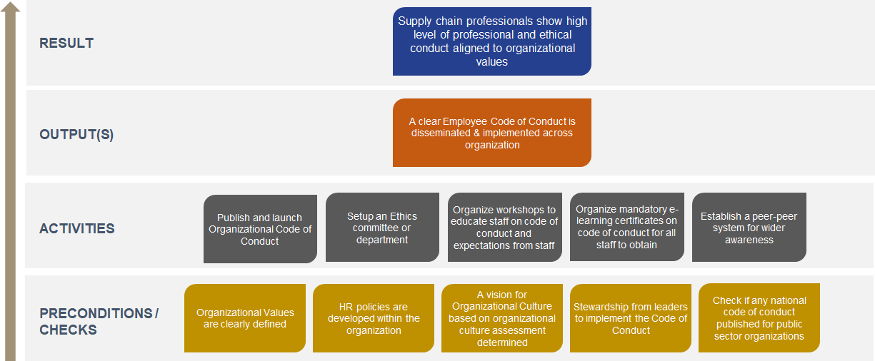
The graphic presents a high-level overview of the logical workflow. Details are provided below.

- Introduction

Health supply chain organisations must ensure that all employees display the highest level of professional, ethical and personal conduct. The purpose of a code of conduct is to set out basic practices for employees and serve as a guide for the standards of professional conduct for all employees. The organizational code of conduct must be based on national rules and address cultural contexts / religious beliefs which affects professionalism, and also align with organizational values linked with business practices of the organization.
In case of a health supply chain organization, the code of conduct must be written in a way to ensure alignment with organizational values, commitment to a culture of responsibility, accountability and ethical practices to save human lives (e.g., a Compassionate, Respectful and Caring attitude by the employees).
In many health supply chain organizations, there are already several policies such as Anti-bribery, anti-corruption, access control, non-disclosure etc. implemented by the organization, however, sometimes the enforcement and implementation of these policies are lacking. The code of conduct should be designed and implemented in a way where the key responsibilities and rights of employees are fully disseminated and understood by them, while the consequences of not following such rules / guidance are made explicit.

- Expected Result

An effective code of conduct helps build citizen’s trust in public sector organizations and creates an environment that attracts talent, investment and recognition.
A comprehensive code of conduct can result in instilling professional and ethical behavior in employees aligned with organizational values.

- Key output(s)

The key output for this initiative should be a comprehensive organizational Code of Conduct which is disseminated and socialized across the organization through various mechanisms to ensure that employees follow those rules, principles and values. A detailed socialization strategy also identifies ways of continuously monitoring the adherence to the code.

- Activities

This initiative aims at comprehensive socialization of the organizational code of conduct, to ensure professional and ethical practices are followed in the organization. The code of conduct must be linked to organizational culture and embedded within the human resources policies for the organization, giving it a legal basis as well. The input for this initiative is the formalized and approved code of conduct with stewardship from the organizational leaders. In order to ensure a successful socialization, implementation and adherence to code of conduct, several activities are required, such as:
- Publish and launch Organizational Code of Conduct: Once the code of conduct is finalized and approved by the leadership of the organization, it must be published as a document (or guide) and launched in an event with several stakeholders and staff members. This will ensure awareness for the code of conduct and will help in smoother dissemination and adoption by various teams. The launch event may be presided by senior government officers such as Minister of Health.

- Setting up an Ethics Committee or Department: Either within the human resources department or standalone, an Ethics (or Code of Conduct) committee / department should be set up, to oversee the socialization and adherence with the code of conduct principles and guidance. The committee or department should be responsible to hear issues and complaints, while also deciding on the consequences during an unethical conduct. The committee should also decide on upgrading the code of conduct when needed and deciding on organizing awareness campaigns as well.

- Organize workshops to educate staff on code of conduct and expectations from staff: After the launch event of the Code of Conduct, several workshops should be organized for various supply chain teams to create awareness on the organizational culture, rules, principles and responsibilities of each employee. The workshop should also discuss characteristics and consequences for unethical / unprofessional behaviors.

- Organize mandatory e-learning certificates on code of conduct for all staff to obtain: The code of conduct guide can be developed into a mandatory e-learning certificate course, which needs to be completed by every employee in the organization. The course can be made mandatory by senior leadership of the organization and some KPIs can be linked to the course too.

- Establish a peer-peer system for wider awareness: Peer-peer mechanisms are always helpful in creating awareness and ensuring adherence to rules / principles. Several champions can be identified within the organization who can set benchmarks for others in professional and ethical conduct. This way staff can be motivated to emulate these employees, thereby resulting in wider awareness and adherence.

- Preconditions and Checks

This initiative is quite important for the supply chain organization in creating a professional and ethical work environment, thereby resulting in better credibility and trust from clients and donors. Hence, several pre-conditions and checks must be met before going for designing and socializing the code of conduct. The key preconditions before this initiative can be funded are:
- Clearly define organizational values: Code of conduct stems from organizational values, which the employees imbibe. Hence, before drafting a code of conduct, it is quite important that the organizational values are defines and known by everyone.
- HR policies are developed and used within the organization: HR policies at an organizational level give legal basis to several process including having a code of conduct. This provides a mechanism for reporting and acting on misdemeanor and finding corrective actions.

Further, before designing the campaign to publish and launch code of conduct, several checks are needed such as:
- There is a dedicated HR department to manage the code of conduct with the committee,
- There is a vision for organizational culture which was developed based on an organizational culture assessment,
- There is stewardship from the leaders who act as role model and inspire employees to follow the principles and values of the organization,
- Checking for national code of conduct guidelines which are mandatory, so that they can also be added to the guide.

- Estimated Timeline

Once the preconditions and checks are met, the initiative may take 12-15 months for completion.

- Key Resources

- Standard Human Resources Policies Package for Health Supply Chain Organizations, People that Deliver, 2021.
- Building Human Resources for Supply Chain Management, Theory of Change, People that Deliver, 2019
- Code of Ethics Toolkit, Ethics Resource Centre, 2001
- Code of Ethics, World Bank Group
- Code of Conduct for Board Officials, World Bank Group, 2018

- Monitoring & Evaluation

Qualitative Indicators | Sources / Means of Verification
- Ability of the organization in implementing the code  - Ability of the leadership in providing an enabling environment  - Feedback from group/department leaders | - Project Reports  - Surveys  - Assessments
Quantitative Indicators
- % staff giving positive feedback to the code of conduct
- Audit rating
- Ethics rating for procurement process
- Number of audits conducted annually

- Incentives & recognition program linked to learning and performance of staff and organization

Category: IMPLEMENT | MOTIVATION
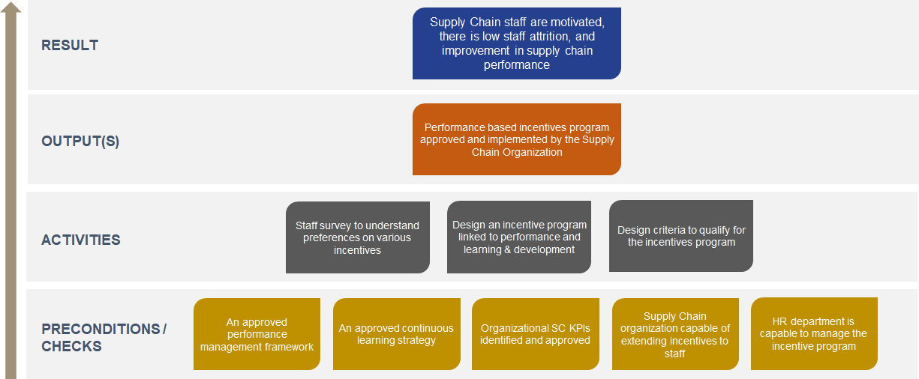
The graphic presents a high-level overview of the logical workflow. Details are provided below.

- Introduction

A key issue that health supply chain organizations across several low- & middle-income countries face is the high rate of attrition of their staff. Sometimes, it may be because of re-assignment or allocation, since the organization falls under government setup, while there are several occasions when staff have left for better job opportunities and higher wages.

Health Supply Chain organizations (like any other organization) have the responsibility to manage turnover and retain supply chain employees by applying different retention strategies. They also ensure that employees are engaged and committed to their work. An incentives (also called rewards & recognition) program can be one of many ways of achieving increased commitment, lower attrition and higher performance.

However, Supply chain organizations should provide a clear, written policy and guidelines describing the reward and recognition (aka incentives) program and its terms. For an incentives / recognition program to be effective, it should meet several criteria.
- The programme should be well-funded,
- It should be aligned with organisational goals, objectives, and KPIs,
- It should be appropriate for employees' achievements and timely,
- It should focus on both financial and non-financial incentives,
- The methods of presenting incentives must be managed well, with managers playing key roles,
- The process for choosing and incentivizing employees should be straightforward, and the program should be reviewed and evaluated regularly.

- Expected Result

Staff recognition and incentives has been identified to be a highly effective motivational instrument, that can have a significant impact on employee job satisfaction and performance as well as overall organisational performance.

Attrition is a key issue in public health supply chains in many countries. Low motivation and lack of benefits are a few critical reasons for employees to change jobs. An incentive and recognition program can increase motivation, improve employee engagement, leading to higher levels of motivation and lower attrition.

- Key output(s)

The key output for this initiative should be approval and implementation of a performance-based incentives and recognition program. The incentives and recognition programs need to combine both financial and non-financial incentives and formal and informal recognition, duly linked with organizational goals and culture.

- Activities

This initiative aims to create a system which can motivate staff to continuously improve their skills and performance leading to better performance of the organization and achievement of the goals. The incentives program, sometimes also referred to as Performance Based Incentives should be linked to the Performance Management framework of the organization and the continuous learning strategy. The rationale for this is as follows:
- Any type of incentive / recognition program must be linked to organizational performance. To be able to do that, the organizational performance management framework (e.g., maturity models) must be linked to employee performance metrics. This is to ensure that improved employee performance must lead to improved organizational performance.
- Learning and development is known to improve career prospects and can act as key incentive. However, if staff are incentivized with further learning prospects, those learning programs must also have a relevance to organizational / departmental functions and performance. Hence, the learning and development strategy must be considered.

The activities under this initiative are designed so as to promote a contextual understanding of the organization before designing the incentive / recognition program.
- Organization-wide staff survey to inform the preferences: Staff in different countries may have different preferences when it comes to incentives and recognitions. Although, the underlying concepts of implementing the program will be same everywhere, the program may not yield intended results if collective staff preferences are not known in advance. Hence, before designing a program, a comprehensive staff survey should be undertaken to understand what is preferred. The results of the survey must inform the design of the program.

- Design of incentives & recognition program: The incentives and recognition program must consider the preferences shown by the staff and discuss with the organizational leadership on possibilities. The program should have both financial and non-financial incentives, and formal and informal recognition linked to performance and achievements. Some non-financial incentives can be opportunities for further learning & development, promotions as leader of a team or department, job rotation, study tours to different country, coaching by an industry leader, fast tracking for leadership role, scholarships for international certification etc. Recognition can include provision of ‘Certificates of Achievement’, Employee of the month, Team recognition etc. Moreover, informal and peer-peer recognition should also be encouraged. In addition to designing the program, organizations should be supported in understanding how to fund these programs and the extend of these programs. The incentives and recognition program may also depend on annual budget cycles, realization of certain organizational targets etc.

- Design criteria to qualify for the incentives program: One of the aim of incentives and recognition program is to improve staff retention. Hence, the program must clearly define which staff are going to be eligible for the program. These criteria need to be designed objectively, but some recognition and rewards can be linked to time spent in organization, certain job grades and profiles. For example, in private companies, some employees may receive stock options of the company if they spend a certain time in the company.

- Preconditions and Checks

This initiative has linkages with organizational performance, learning & development and human resources management. Hence, there are several pre-conditions and checks, before this program can be designed. Although, an incentive program can be developed without fulfilling these pre-conditions, the impact of the program may be lower if those pre-conditions are not fulfilled.
The key pre-conditions are 1) presence of an approved performance management framework to inform organizational and employee performance. This is important to provide an objective criterion to measure employee performance to approve the incentives and recognitions. Without this, the awarding may be quite qualitative/subjective and may result in resentment in employees who are not awarded. 2) presence of a continuous learning & development strategy. This will help develop several non-financial incentives and also help the staff in advancing their career. When staff are provided opportunities for further learning, they should be linked to the organizational objectives.
Further, before designing an incentives program, several checks are needed such as:
- If an organizational supply chain KPIs are identified and approved, to track organizational performance over a period.
- If the supply chain organization is capable of extending financial incentives to staff, and the HR policies / laws permit this.
- There needs to be comprehensive HR policies in the organization which support the incentive scheme.
- Finally, the organization should have a dedicated HR department to manage, document and report the incentives program.

- Estimated Timelines

Implementing the incentive and recognition program may take between 15-18 months, with a long time to design and finalize the staff survey and getting approval for the program based on budget.
- Key Resources

- Standard Human Resources Policies Package for Health Supply Chain Organizations, People that Deliver, 2021.
- Building Human Resources for Supply Chain Management, Theory of Change, People that Deliver, 2019
- Guidelines: Incentives for Health Professionals. World Medical Association. 2008
- Improving health worker performance: in search of promising practices. World Health Organization. 2006

- Monitoring & Evaluation

Qualitative Indicators | Sources / Means of Verification
- Approved incentives and recognition program implemented by the organization  - Feedback from employees | - Project Reports  - Surveys  - Assessments
Quantitative Indicators
- Budget allocated for incentive / recognition program
- Net Promoter Score survey results
- Annual attrition rate
- Number of awards
- Amount spent as financial incentive
- Performance score of employees (before and after the program)

- Integration of Supply Chain Curriculum in Health Degree Programs

Category: SUSTAIN | STAFFING
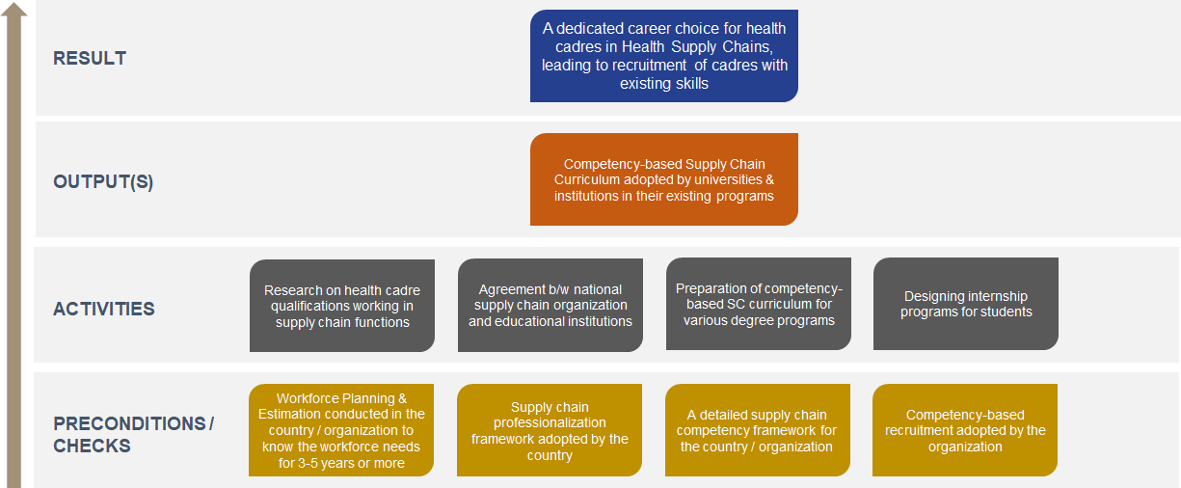
The graphic presents a high-level overview of the logical workflow. Details are provided below.

- Introduction

Professionals working in Health Supply Chains have mostly entered the profession by chance rather than a career of choice. Most of the professionals currently working in health supply chains are pharmacists, nurses, pharmacy technicians, general management graduates and sometimes doctors. The health sector has not always been able to attract supply chain professionals for supply chain roles in the public sector since the private sector supply chain jobs are more attractive than public health sector jobs. Moreover, the supply chain roles are not always designed to attract supply chain professionals.
Hence, health graduates mostly find themselves in these jobs where the job profile requires them to assume and carry out supply chain functions. However, in most of the curricula for these health programs (e.g., pharmacy, nursing, technicians, medicine, general health management etc.) supply chain does not feature in the curriculum. In several pharmacy curricula, drug management is included, which focusses on managing products in a pharmacy or a hospital. However, this does not prepare the student for the rigors of the industry, and hence, when recruited by a national / regional / provincial supply chain organization or Ministry of Health, they are put into internal capacity development programs.
If, in future, the trend of recruiting health graduates for supply chain roles need to continue, a key pre-condition needs to be set in by the health supply chain organizations, that health graduates must be initiated in supply chains during their degrees so that it can become a career of choice, and recruited professionals already have key skills for the job.

- Expected Result

Mainstreaming supply chain roles and education within the health education systems will result in creation of a new career path for graduates where not only they can enter into the public health system but can also become eligible to compete with supply chain graduates for supply chain roles in the private health sector (e.g., manufacturers, distributors, freight forwarders etc.).
This will also lead to national public health supply chain organizations to recruit and invest in individuals who already have key supply chain skills and can be quickly initiated to the organizational objectives. This will also result in spending less funds for developing capacity of the staff in supply chains, which can be diverted for creating incentives scheme for the staff in the long run.

- Key output(s)

The key output for this initiative should be development of a competency-based supply chain curriculum and program which is integrated into the existing health programs in the national universities and institutions. The new program can be integrated as a mandatory subject in a semester or an elective subject for the students depending on choice.
- Activities

This initiative aims to create a sustainable labor market for the national supply chain organizations by working with national universities and institutions and integrating supply chain in the existing curricula. This initiative requires extensive advocacy and understanding of demand and supply factors in the labor market. The demand for health graduates with supply chain competencies must come from Ministry of Health or National health supply organization, based on which national universities / institutions can respond and adapt their approach for health degrees.
This initiative must be conducted at a country-wide scale so that adequate demand can be shown to change current practices. The following activities can be pursued towards this objective:
- Country-wide research on qualifications of health cadre involved in supply chain: Extensive advocacy is required to change deep-rooted practices and advocacy requires research. The first step towards this initiative should be a country wide research, to understand the qualifications of all those health cadres who are engaged in supply chain functions. These functions can be at the central level (at CMS level), or can be at the regional / provincial, going up to the health facility level. The objective of the research should be to understand if they staff employed at various levels had any of the respective supply chain skills (based on their job role) when they joined the sector, and if they were prepared for some of these job functions by their degrees. The research can also look at how many cadres invested in a secondary degree (e.g., master’s in supply chain) or have attended supply chain training & workshop while being in the role. The research can also look at the financial aspect, e.g., how much on average is spent annually to develop basic supply chain skills in the entry to mid-level workers. The output of the research will lay the foundation for a dialogue between various stakeholders like supply chain organization, ministry of health, ministry of education, universities, and institutions.

- Agreement between Ministry of Health / National Supply Chain Organization and educational institutions: Once the recruitment strategy is finalized by the supply chain organization, agreements can be signed with national institutions to include supply chain curricula in their existing health degree programs. The agreement can also include internships for the students at the supply chain organization and preferential recruitment for students who have completed the supply chain curricula during the programs. Here, other private sector health organizations (such as manufacturers, distributors) can also be reached out to see their preference in recruiting students with supply chain curriculum in their programs.

- Preparation of competency-based supply chain curriculum for various degree programs: A competency-based supply chain curriculum should be prepared in collaboration with the universities which they can embed in their existing programs. The curriculum should be developed in a way that includes key tasks and associated skills that are performed by staff in their jobs, emphasis being given on skills. The curriculum should be developed for students ideally in their final (or penultimate) year of studies so that they can readily apply the skills if they join the organization. The curriculum could include internships for students so that it helps them understand the actual work even before they join the workforce.

- Design internship programs for students: Internship programs can be designed for students from the universities who sign the agreement where the students can spend up to 3 months (depending on their program curriculum) with a supply chain department learning and working on supply chain functions. The internships can be based at the central level, or at any other level of operation. The objective of the internship should be to raise student’s interest in supply chain as a profession while identifying students for future recruitment.

- Preconditions and Checks

Since this initiative is at the far end of the spectrum in the EDIS model, there are several pre-conditions and checks which are required even before this initiative can become a reality. The key pre-condition is Workforce Planning and Estimation of staff requirements over a long term (demand of cadres), which will be critical in creating advocacy amongst the universities. The workforce planning and estimation will work best if conducted at the national level, also involving staff from lower levels of supply chain operations. However, it will depend on the national supply chain organization and their scope of activity.
In addition, other checks need to be made while planning for this initiative such as:
- Supply Chain professionalization framework adopted by the country: This will help new cadres understand their career pathway when they decide to join the section and help them make decision about supply chain career by choice.
- A detailed supply chain competency framework for the country or organization: A supply chain competency framework is essential, if a competency-based curriculum needs to be developed.
- Competency-based recruitment strategy: The supply chain organization should adopt a new recruitment strategy where the focus should be on supply chain skills along with educational credentials. This way, students will invest in learning supply chain during the degree courses.

- Estimated Timelines

This is a long-term initiative and may take up to 2 years to fully implemented.

- Key Resources

- Standard Human Resources Policies Package for Health Supply Chain Organizations, People that Deliver, 2021.
- Building Human Resources for Supply Chain Management, Theory of Change, People that Deliver, 2019
- Library of Competencies and Designations for Health Supply Chains (developed by People that Deliver)

- Monitoring & Evaluation

Qualitative Indicators | Sources / Means of Verification
- Health cadres qualification research accepted by National Supply Chain organization, Ministry of Health and Educational institutions  - Successful agreement between supply chain organization and educational institutions for embedding curriculum in existing programs  - Competency-based curriculum and program accepted by institutions | - Project Reports  - Surveys  - Assessments
Quantitative Indicators
- Number of institutions signing the agreement
- Number of students enrolled in the new curriculum
- Number of internships finalized

- Continuous learning strategy in National Supply Chain Organization

Category: SUSTAIN | SKILLS
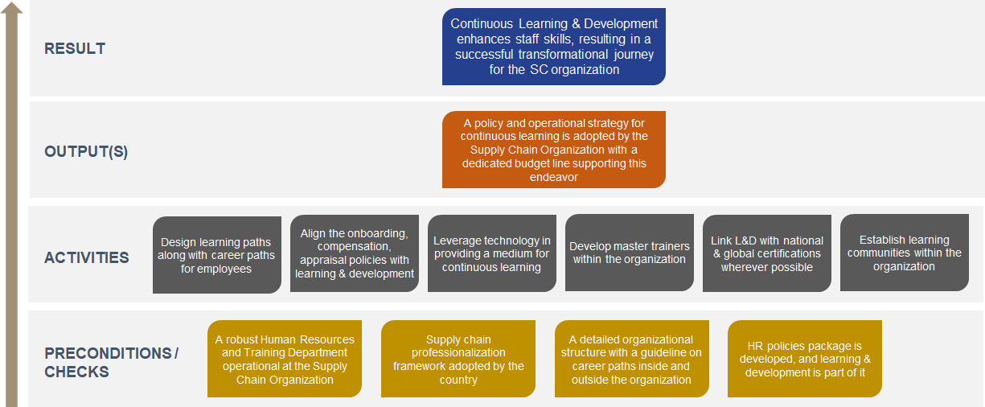
The graphic presents a high-level overview of the logical workflow. Details are provided below.

- Introduction

Commercial supply chains operate in quite a competitive market where new processes and innovative technologies are adopted often to improve service delivery and bring down costs. A recent study by Mckinsey and company on 54 large companies engaged in supply chain across Europe, America, and Asia reported that ‘Capability Growth’ is one of the six drivers of continuous growth, resulting in high performing organizations. It is also a widespread understanding that 70% of all transformation programs fail because employees did not have the necessary skills and capabilities to support the transformational change. This is also quite reflective of the public health supply chain, where several transformation programs did not yield the intended results because the skills were brought from outside rather than developing them within the supply chain organization.
Although, training and capacity development are quite widespread and mainstream in many national supply chain organizations and associated organizations working in the health system, they are often not linked with the transformational goals. Moreover, quite often training is ad-hoc and does not provide visibility on the career paths for employees. This results in high attrition and staff changing jobs once they acquire certification.
A comprehensive continuous learning strategy will support the acquisition of skills for employees over a longer of period of time, enabling the supply chain organization’s transformation strategy. In longer term, a continuous learning strategy can lead to development of high-performing teams, who are able to operate with a strategic orientation in improving the access of medicines.

- Expected Result

Learning & development has a direct impact on staff performance and motivation, and when continuous learning strategies are employed for a longer period, it supports the supply chain organization’s transformation journey.
However, this is only possible when the learning strategies are aligned with the transformation goals, with a key focus also provided on employee career paths.

- Key output(s)

The key output for this initiative should be a policy and operational strategy for continuous learning, that is adopted by the supply chain organization. The strategy should be:
- accepted by all partners supporting the organization,
- linked to transformational goals
- fully costed and budgeted for 3-5 years & source of funds identified
- led by in-house Human Resource or Capacity Building/Training department

- Activities

Learning and development is a game of repetition, practice and ultimately, measurable growth. Continuous learning is a key requirement for professionals to go from an associate designation to an expert / leader designation in a professionalization framework. Together with work experience, learning prepares a supply chain professional (or a health professional engaged in supply chain) for the rigor of the sector, and opens up opportunities to embrace new technologies, ideas and processes. This ultimately helps the organization in achieving their targets (e.g., reducing stock outs, efficient inventory control, better pricing models, improved service delivery etc.).
An initiative focused on establishing a continuous learning system in a national supply chain organization must have a long-term view, where the organization must monitor and evaluate the results over 3-5 years. However, in the beginning, they may need to dedicated support in instituting such a system. This is where key support can be provided by local and international service providers. While there can be several strategies in implementing such a system, the following activities can guide the process:
- Designing career and learning paths for employees: A key method of continuous learning is to develop learning paths for employees for them to understand how they can improve their skills over a period. However, learning paths must also be aligned with career paths so that staff understand how their professional career can grow with the organization. This activity must align itself with the professionalization framework, organizational hierarchy and job grades prevalent in the organization.

- Aligning learning & development with key HR policies: The beginning of Continuous learning opportunities should begin as soon as onboarding of a new staff and should also be aligned with the appraisal cycles. Employees should be given learning targets linked to their job roles, and appraisals should account for the new skills obtained. This means that some of these HR policies needs to be modified and aligned to the new strategy of learning & development. This may not be entirely possible in some countries where the appraisal methods are tightly controlled under labor laws and must then be managed accordingly.

- Develop in-house Subject Matter Experts and Master Trainers: For a more effective continuous learning strategy, the supply chain organization must have in-house SMEs and trainers. In the beginning of this program, external trainers and SMEs can implement the strategy, however, for long term sustainability, the goal must be to have in-house staff leading the learning journey. Moreover, in-house staff would have more understanding of the organizational and country’s culture which can led to better contextualized delivery of learning content.

- Establish learning communities within the organization: The impact of learning & development programs is much higher when personnel in an organization learn together. Since, supply chain functions are interconnected and requires deep rooted teamwork in achieving program targets, learning & development strategies must also include establishing internal (& external) communities of staff members who can learn together, discuss issues within their work functions and derive solutions in a more collaborative manner. Several supply chain communities are already existing globally (e.g., IAPHL), and similar communities can be developed within an organization leveraging newer technologies.

- Leverage technology in providing a medium for continuous learning & community management: Wherever possible, depending on the internet coverage in the country, technology needs to be leveraged in creating medium for continuous learning and community management. Training programs can be delivered using online platforms (LMS) in several ways, such as self-paced learning, instructor led sessions, peer-peer sessions and masterclasses. Moreover, technology can be used to establish online communities where staff across the country can collaborate, learn and network.

- Link continuous learning opportunities with national and global certifications: Continuous learning is often synonymous with career growth, and certification is a key incentive for staff to continuously learn new skills. Hence, efforts must be made to link the learning courses with national certifications such as with universities, CPD councils and international certifications. This will have a tremendous impact on staff morale and confidence as well.

- Preconditions and Checks

A key pre-condition for establishing a continuous learning strategy is the presence of a dedicated Human resources and/or capacity building department in the supply chain organization. Since, the strategy for continuous learning is long term, with several linkages to HR processes, without a dedicated HR department, management of such program will be quite difficult. The program will require development of HR records, learning and career pathways, updating them continuously, recording training needs of staff and their progress while amending some of the HR processes and aligning them with learning & development. Some of these activities can be led by an external partner agency for a while, but for long term management, the absence of a HR department will be detrimental to the program.
In addition, before embarking on a continuous learning program, a few checks must be made on:
- Whether the organization has developed and established a professionalization framework,
- Whether there is a detailed and structured career path guidelines for the staff exist, and,
- Whether HR policies package have been developed with learning and development in it.

The continuous learning strategy should only be developed if the above preconditions are met.

- Estimated Timelines

This is a long-term initiative, and since it is under the Sustain phase of EDIS, the key objective is to ensure that the national supply chain organization is able to sustain the continuous learning strategy. The initiative can also be broken down into two to three phases, with each phase taking close to 12 months to complete.

- Key Resources

- HR Career Framework Guide. CIPD. Civil Service HR, Government of UK, 2020
- Point of View, Building for an Unknown Future, Leap Forward with a Career Framework. Mercer. 2017
- Operations and Supply Chain Management Career Paths and Patterns. APICS. 2014
- The framework for continuous learning in Social Services. Scottish Social Services Council. 2014

- Monitoring & Evaluation

Qualitative Indicators | Sources / Means of Verification
- Continuous learning strategy accepted by the country leadership  - Positive impact on staff from continuous learning opportunities  - Career and learning paths developed and accepted in the supply chain organization | - Project Reports  - Surveys  - Assessments
Quantitative Indicators
- Attrition rates
- Number of staff enrolled into continuous learning pathways
- Number of staff who were promoted after obtaining key certifications
- Competency Profiles
- Number of active staff in communities
- Number of CPD hours completed

- Work environment supports physical, social, and emotional well-being of staff

Category: SUSTAIN | WORKING CONDITIONS
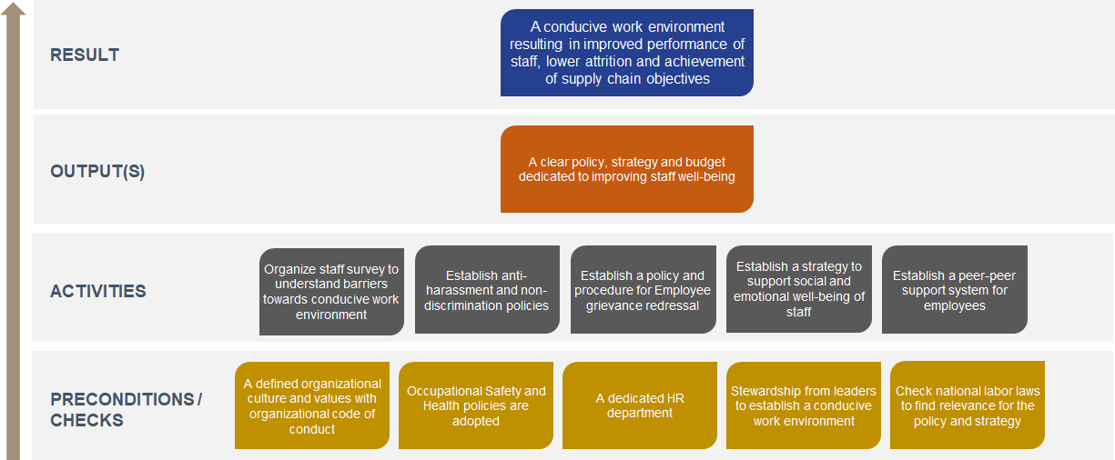
The graphic presents a high-level overview of the logical workflow. Details are provided below.

- Introduction

As health supply chain organizations mature, they will need to invest in their staff in order to maintain the supply chain performance. It is well known that Motivated and competent workers, possessing the skills and capacity to operate the supply chain effectively and efficiently, are crucial to the performance of the supply chain. However, for continued performance (or to create high performance teams), it is equally important to create a conducive work environment which looks at physical, social and emotional well-being of the staff. A highly conducive work environment requires a comprehensive organizational culture, a dedicated human resources unit looking after the well-being of the staff and policies and processes that promote a safe work environment (not just physically, but emotionally and socially too). As the basic needs of the employees are fulfilled by the organization, they can focus on improving the service delivery. Several health supply chain organizations (e.g., CMS, LMCUs etc.) in low- and middle-income countries may be quite far from this objective, but it is important to know the requirements of creating such a work environment.

- Expected Result

A conducive work environment results in improved capabilities of a worker to perform her/his duties, resulting in improved performance of the organization as a whole. Positive work environment that supports physical, emotional, and social well-being of the staff retains more staff and attracts new talent.

- Key output

The key output for this initiative should be an approved policy, strategy, operational plan with a budget to implement and socialize the guidelines for establishing a positive work environment with emphasis on employee physical, social and emotional well-being. These policies and processes, however, should align with national labor laws to ensure smooth implementation.

- Activities

This initiative aims at creating and sustaining a work environment where staff are valued, their physical, social and emotional well-being are addressed in order to equip them for the rigors of the sector. The policies and strategies to improve work conditions and empower staff should be based on collective inputs taken from them, with stewardship from the organizational leaders. Several activities are required in order to streamline this initiative:
- Organize staff survey to understand barriers towards conducive work environment: The strategy and processes for creating a conducive work environment must stem from the key barriers faced by employees during their regular work environment. Hence, a detailed staff survey, interviews and focus groups should be organized to understand the key issues and likely resolution ideas as per national laws and policies. These issues and possible resolutions should also be presented to the leadership for them to understand how employees rate the current work environment.

The following activities are examples and suggestions; however, it is expected that activities will be designed based on the staff survey.

- Establish anti-harassment and non-discrimination policies: Anti-harassment laws or policies may not always be part of regular HR policies in a health supply chain organization. The purpose of anti-harassment and non-discrimination policy is to ensure that HSC organization workplaces are free from discrimination and harassment and that such behavior is not tolerated. Harassment is considered any behavior by an employee (most often by someone at a position of power) that is directed at and is offensive to others which that person knows or should reasonably know, would be offensive, and which interferes with work or creates an intimidating, hostile or offensive work environment. Harassment includes discriminatory conduct, comments or displays related to race, religion, color, creed, ethnic origin, physical attributes, age, gender, disability or sexual orientation. Harassment should not be confused with provision of guidance or counselling on work performance or other work-related corrective feedback.

If such a policy is not part of standard HR policies and these issues arise out from the survey, then a policy should be drafted with procedures to support staff who face such harassment and discrimination, preventive / corrective measures with reporting, complaint, consequences and appeal information and procedures.

- Establish a policy and procedure for Employee grievance redressal: Employee grievances may arise as a result of dissatisfaction with working conditions or decisions taken by the management of an organization. This could include complaints about their employment situation or disagreements with their supervisors or peers. Health supply chain organizations should ensure that employees’ grievances are addressed promptly and in an objective and transparent manner. Employees should also be encouraged to present their grievances to the appropriate authority (e.g., HR Unit) without fear and through the proper channels. Employees should also be given the opportunity to present their grievances to the highest decision-making authority through the channel if their complaints are not resolved by their supervisors or assigned personnel.

If such a policy is not part of standard HR policies and these issues arise out from the survey, then a policy should be drafted with procedures to support staff in voicing their grievances.

- Establish a strategy to support social and emotional well-being of staff: Social well-being can be defined as the sharing, developing, and sustaining of meaningful relationships with others. This allows employees to feel authentic and valued and provides a sense of connectedness and belonging. Mental health (or emotional well-being) problems have many effects on the individual at the workplace. The productivity of individuals with unsupported mental health needs may decline while at work. Mental health problems can affect work performance in terms of increase in error rates, poor decision-making, loss of motivation and commitment, tension and conflicts between colleagues. Burnout and depression as well as stress related physical conditions such as high blood pressure, sleeping disorders and low resistance to infections can result in an increase in overall sickness absence, resulting in lower performance.

Hence, it is quite important for matured health supply chain organizations to invest in improving social and emotional well being of their staff in an effort to continuously improve organizational performance. This can include several measures like organizing Team Days for employee social interaction, organize community activities or wellness days, establish practices to support pregnant and lactating women, promoting the culture of mental well-being, organizing life-coaching sessions etc.

- Establish a peer-peer support system for employees: Since employees spend between 40-50 hours with fellow employees, it is important for organizations to help them create meaningful connections. Employees should be able to share issues with their peers and find resolutions within their peers. This can promote an informal culture of problem solving which can also support work related issues.

- Preconditions and Checks

This initiative falls under the ‘Sustain’ bucket of the EDIS model, which means that several workforce development initiatives need to happen before this. Moreover, at the sustain bucket, initiatives should be designed in a way to ensure that the national organizations are able to sustain them (possibly without external support). Hence, the key preconditions before this initiative can be funded are:
- Clearly defined organizational values and culture: Employee well-being should be part of organization’s culture. Employees must see that the organization is making effort in ensuring their all-round well-being and that the culture promotes a conducive work environment. Although, the workplace policies can be drafted and implemented without a defined organizational culture, but the impact can increase multifold if culture and values are documented.
- Occupational Safety and Health Policies are already adopted: OSH ensures physical well-being of the employees. For example, workers in a warehouse must have a proper dress code and protective equipment (e.g., Helmets). Organizations can also invest in modern Material Handling Equipment so that physical stress can be removed. If OSH policies and mechanisms are not implemented, they should be implemented in priority as part of this initiative.

In addition, before designing this initiative, several checks are needed such as:
- There is a dedicated HR department to manage the strategies developed under this initiative,
- There is stewardship from the leaders who act as role model and inspire employees,
- Checking national labor laws to ensure that such initiatives can be implemented in a given country (post donor support).

- Estimated Timeline

This initiative may take up to 2 years to fully complete with appropriate time required to understand staff opinions, develop policy framework and support national organization to allocate budget.

- Key Resources

- Standard Human Resources Policies Package for Health Supply Chain Organizations, People that Deliver, 2021.
- Building Human Resources for Supply Chain Management, Theory of Change, People that Deliver, 2019
- Promoting Employee Well Being, Wellness Strategies to Improve Health, Performance and the Bottom Line. David Chenoweth. SHRM. 2011
- Emotional Health at Work. IPPR UK. 2018
- WHO Healthy Workplace Framework and Model. Joan Burton. 2010

- Monitoring & Evaluation

Qualitative Indicators | Sources / Means of Verification
- Results from Staff survey are accepted by the organization’s leadership  - Policies are approved, budget allocated and implemented by the organization  - Feedback from staff | - Project Reports  - Surveys  - Assessments
Quantitative Indicators
- Staff survey on acceptance for new policies
- Net promoter score survey
- Attrition % after 1-2 years of implementation of policies, procedures
- Supply chain KPI analysis post implementation of these policies

- Continuous supportive supervision to improve staff performance

Category: SUSTAIN | MOTIVATION
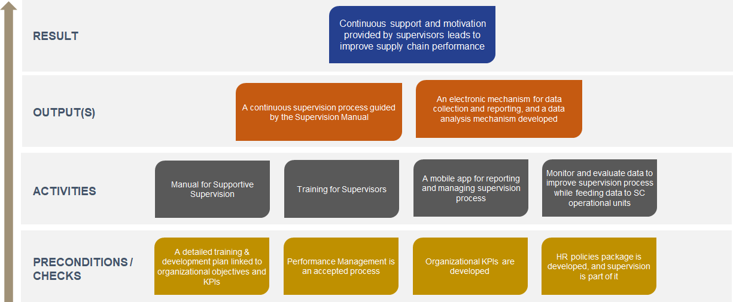
The graphic presents a high-level overview of the logical workflow. Details are provided below.

- Introduction

Supportive supervision is a process of helping staff to continuously improve their own work performance. It is carried out in a respectful and non-authoritarian way with a focus on using supervisory visits to improve knowledge and skills of health staff. It encourages open, two-way communication and builds team approaches that facilitate problem-solving. It focuses on monitoring performance toward goals and using data for decision-making. It depends on regular follow-up with staff to ensure that new tasks are being implemented correctly. (WHO, 2004).
For a supply chain operation in a country, supportive supervision can involve the following staff members:
- Supervisors: health service delivery/supply chain implementing partners; national, regional, or district health and/or supply chain managers, officers who are engaged in leading teams.
- Supervisee: frontline health workers, for example workers who manage immunization or who conducts HIV Tests in a facility, pharmacists, supply chain workforce, and community-based health workers. The supervisee workplace or site includes public and private sector health facilities, hospitals, clinics, medical stores, pharmacies, and other health sites in urban and rural locations. They can also be junior team members in a warehouse, a procurement office.

The objectives of a supportive supervision program can be multifold:
- Ensuring full understanding of a new program or process by the staff,
- Stock management and inventory control at various sites, & quality of reported data,
- Monitoring application of new skills learnt during a training program,
- Gathering critical datasets from various sites to understand supply chain performance.

Supportive supervision can be conducted by various methods such as site visit to supervisee workplace, monitoring calls (can be group calls), and meetings. Supportive supervision can also take the form of On-Job Training in some instances.

- Expected Result

Motivation is one of the four key pathways leading to optimization of work performance, resulting in supply chain effectiveness and availability of commodities at service delivery points. A motivated supply chain staff manages their work optimally, leading to improved performance of the system.
Continuous supervision and support can be a factor in improving staff motivation and morale which in effect can improve system performance. Supportive supervision should be embedded in training & development programs / cycles whereby a team of supervisors need to be trained to interact with supply chain staff continuously and supporting them manage their work effectively.

- Key output(s)

The key output for this initiative should be a continuous supervision process guided by the Supervision Manual, with an electronic mechanism for data collection and reporting, and a data analysis mechanism.
Supportive supervision must be supportive in nature, meaning it must empower the staff in implementing their work more effectively. With regular supervision, supervisors can also get to know some key root causes of issues faced in the supply chain and can weed out the issues by working with the staff. A comprehensive supervision program should also be able to collect relevant data at frequent intervals to continuously analyze and report some KPIs to monitor system performance.

- Activities

Supportive supervision can be a resource intensive program and hence needs to be planned in close collaboration with the supply chain organization. Several technical agencies have been focusing on supportive supervision, but several times, the supervision is conducted by the staff of the technical agency rather than the supply chain organization. While it is a good practice in the beginning, the objective should be to develop supervisors within the organization and create pathways for this activity in a continuous manner. Budget can be an issue for a long-term supportive supervision structure and hence sustainable methods need to be identified.
Keeping this in mind, the following activities can be undertaken while instituting a supportive supervision program:
- Developing a detailed manual for supportive supervision: The supervision process must be conducted in a non-authoritarian manner with an objective to support the work performance of staff. However, it can be quite difficult to achieve without a set of guidelines or manual. Hence, the Supportive Supervision manual can help in setting the standards, process and support supervisors in clearly understanding the objective of supervision and how to do that. The manual should also have job-aids, checklists, monitoring tools etc.

- Training of Supervisors: A pool of supervisors must be selected in collaboration with the supply chain organization. This pool must be trained on the process of supervision and how this activity will benefit the organization and their own role. The training may include shadowing, sample supervision visits, and data collection & analysis procedures.

- Developing a mobile application to support data collection and analysis: A key requirement for any supervision visit should be collection of data, such as, on KPIs related to inventory management (e.g., Stock on hand, Expiries, damage etc.), consumption data for a facility, storage conditions of products and any other data related to system KPIs. Supervisors should be able to collect key datasets during their supervision visits which can then be compiled and discussed with Managers and Leaders.

- On-Job Training: The supervisors should be able to identify key issues in the process followed at various sites and then provide hands on training to the staff. These issues can be identified in one visit, and then discussed with senior managers before organizing the hands-on training.

- Monitor and Evaluate Supervision process: Through the mobile application, data on effectiveness of supervision can also be collected from the recipients. This way, supervision process can be improved.

- Preconditions and Checks

The policy and manual for Supportive Supervision must be part of overall Human Resources policies package for the supply chain organization. The supportive supervision manual must also take into account the KPIs for measuring performance of the organization as part of the performance management framework or guide.
Without the performance management guide and practice, the impact of supportive supervision practice will be partial as it will be impossible to understand how supervision led to improvement of the system and processes.
From a training & development perspective, the supervision plans should also be embedded in the overall training plan, where supervision can be a method to ensure new skills are used after a training session. The supervisors can also be engaged in On-Job Training as per the training plan. Hence, a pre-condition should be presence of a detailed training plan where supervision can be embedded.

- Estimated Timelines

This initiative may take 12-15 months to complete with the service provider also supporting the national supply chain organization in understanding the data collection, analysis and reporting mechanism.

- Key Resources

- Standard Human Resources Policies Package for Health Supply Chain Organizations, People that Deliver, 2021.
- Building Human Resources for Supply Chain Management, Theory of Change, People that Deliver, 2019
- Children’s Vaccine Program at PATH. Guidelines for Implementing Supportive Supervision:A step-by-step guide with tools to support immunization. Seattle: PATH (2003).
- Ministry of Health. Supportive Supervision Manual for Health Products and Technologies. 2020. Nairobi, Kenya.

- Monitoring & Evaluation

Qualitative Indicators | Sources / Means of Verification
- Improvement of supply chain skills in staff,  - Positive impact on staff as a result of the supervision process,  - Supervision is accepted as a capacity building method. | - Project Reports  - Surveys / Assessments
Quantitative Indicators
- Net Promoter Score metrics
- Number of supervision visits,
- Number of checklists filled,
- Number of active users on Mobile App,
- Number of OJTs completed,
- Improvement in KPIs (linked to supervision process)

https://www.mckinsey.com/business-functions/operations/our-insights/how-great-supply-chain-organizations-work

